**Ahmed Hassan Ismail – BESE-9B – 237897**

**OS Lab 5**

**Mam I have used Linux on my cousin’s laptop as few days ago my laptop’s hard drive crashed due to some installation error done from my end. From next Lab onwards I will be using my own Linux. Thanks for cooperation.**

**Task 1:**

**Code:**

#include<stdio.h>

#include<unistd.h>

#include<stdlib.h>

#include<sys/types.h>

#include<sys/stat.h>

#include<unistd.h>

#include<string.h>

#include<fcntl.h>

void totalLength(char *argv[])

{

int fileDescriptor=0;

int readFile = 0;

int numberOfLines=0;

char bufPointer;

char buffer[80];

int user = atoi(argv[1]);

int number=0;

int indexNumber= 0;

if((fileDescriptor=open(argv[2],O_RDONLY)) != -1)

{

while((readFile=read(fileDescriptor,&bufPointer,sizeof(char)))!= 0)

{

if(bufPointer != '\n')

{

buffer[indexNumber]=bufPointer;

indexNumber++;

}

else

{

if(number>user){

printf("%s\n",buffer);

}

else{

indexNumber = 0;

}

number++;

}

}

}

}

int main(int argc,char *argv[])

{

struct stat buf;

if(argc==3)

{

if(stat(argv[2],&buf)==0)

totalLength(argv);

else

{

perror("stat()");

exit(1);

}

}

return 0;

}

**Screenshots:**

File that was used for reading:

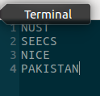

**Task 2:**

The inode of the file1:



The hardlink created between file1 and file2:



File 2 exists now.

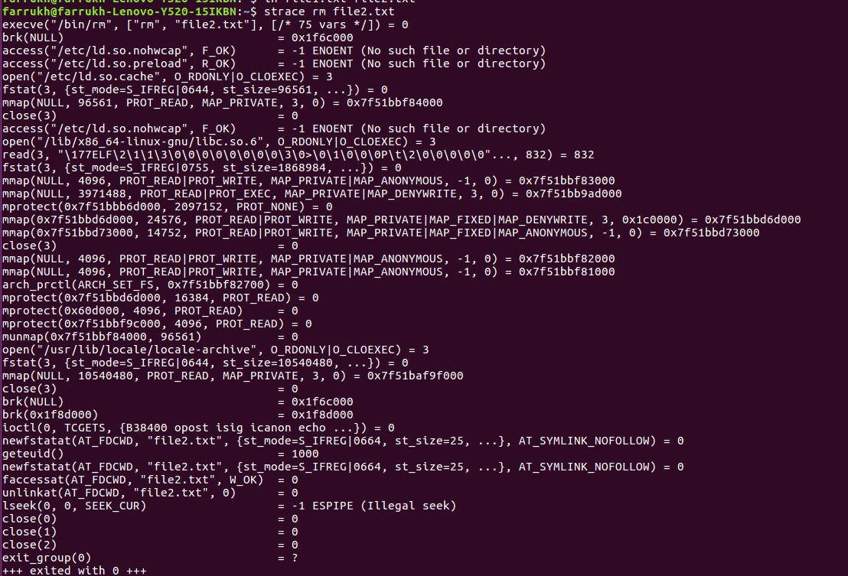

File 2 now removed.



The inodes are not same of both the files.

The changes in file3 is reflected in file4 as well.

Both the files get deleted without any error.